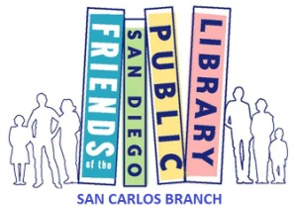
San Carlos Friends of the Library
(sancarlosfriendsofthelibrary.org)
Book Donation Guidelines

We love to have your gently used book donations. Without them, we would not be able to hold our Monthly First Saturday Used Book Sales, the proceeds of which are donated to the San Carlos Branch Library to purchase new books, equipment, and programs. With your donations and the 3000 hours annually donated by our volunteers, we are able to donate approximately $23,000.00 annually to our branch library.

We do understand how painful it can be to dispose of a beloved book. However, to help us streamline the sorting and organization process of donated books, we are asking that you keep the following Book Donation Guidelines in mind before dropping off your donations:

- Check your books over carefully:

- If they have been stored in a garage, attic, or storage facility for some time, they may be covered in dirt, mold, insects, spiders, or other pest residue. We cannot sell dirty books—please discard them. If you do not want to touch them, neither does anyone else.
- If the pages and covers are coming out and off of your books, or if they are soiled with food and drink, they will not sell. Please dispose of them.
- Make sure you have not included library books or books you want to keep. It’s really difficult to find them again amongst the many.

- When and Where to place your gently used--donated, treasured books:

- If possible, drop off your donated books at least 3 days before a sale date. Our Monthly Used Book Sales are held the First Saturday of every month. Exceptions may occur if a Holiday Library closure occurs on that weekend, then it may be rescheduled. The website and library calendar will keep you updated.
- Try to bring your donated books to the library when it is open. There are labeled donation carts located inside the library’s north/west entrance on which you can place your donated materials. If this doesn’t work for you, please place your labeled, bagged or boxed donations on the cement bench outside the north/west entrance.
- Take Care: Do not use the outside book returns for donated books. It produces more work for our librarians and delays their sorting for the next book sale.

The San Carlos Friends of the Library is indebted to the wonderful community members who donate their gently used books, the book sale volunteers and patrons.

