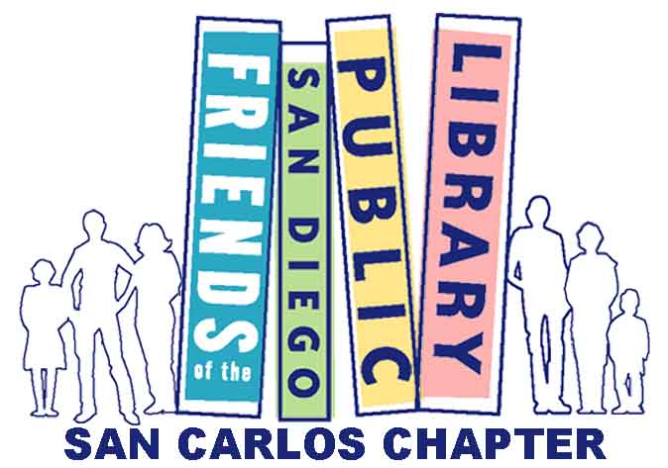

MEMBERSHIP
There are a variety of membership levels.
One will be right for YOU!
Annual Memberships
Individual Senior/Student $5
Individual Adult $10
Family (Dual Adult) $20
Sponsor $50
Contributor/Business $100

Lifetime Memberships
Individual Life Member $250
Patron $1000

0
Your gift today will be doubled through a special matching fund, meaning it has twice the impact on Library programs, books, materials and technology.

With your gift of $100 or more, you will become a member of the Library Foundation’s Donor Circle and qualify for unique Library access including Library Shop discounts, behind-the-scenes tours, and exclusive invitations to special events.

Join The Carnegie Society by naming the San Carlos Branch Library in your estate plan
- Through a will, living, trust, insurance policy, or retirement account, or
- Through a planned gift such as a charitable remainder trust, charitable gift annuity, pooled income fund, donor advised fund, or charitable lead trust.

For more information about becoming a member of the Carnegie Society by naming the
San Carlos Branch Library as a beneficiary, please contact the
San Diego Public Library Foundation at (619) 238-6638.

